Employee Management System

# Introduction:

In the ever-evolving landscape of technology where everything changes day by day and things become more professional and good and as well as these modern technologies save human power and time. These technologies help in many ways whether they help in daily tasks or remote work in every field these technologies help people. In this modern era where all things are run on the tips, every organization whether these organizations are big or small they changed their way of work from old to modern for example as seen in this era organizations use database management systems for storing all the information and data, but in the previous time, the file management system is used instead of a database. In this file management system

The database was developed in the early 19’s and day by day the database is used in every firm the importance of the database is increased now for every data storage the database system is utilized and this database can help in many scenarios and this database management system also enhance the working experience and make the whole work easy and efficient.

In this assessment, the work is on the employee management system. This system manages a large dataset of employees and handles or stores all the information related to the employees. After this, there is a part of some queries that are to be implemented to manipulate the employee data. Like searching for a particular employee and more like, these small tasks help in understanding the database and their related queries so it is a real-world task it also increases the confidence in doing such tasks. After reading this comprehensive report the reader will easily understand the use of the database in the employee management system.

## Database Questions:

There are several questions are asked in the assessment which have to be answered by writing the database queries this report contains all the answers to the questions and also with their respective screenshots of the output of the code are added to the report so the whole work becomes easy to understand by the reader . There is a total of 9 questions are asked and one by one all the questions are answered. The answers are as follows

### Question 1:

***Add a new attribute called "EmployeeInitials" to the Employees table.***

**Query**:



This is the query of this question to add the new attribute in the employees' column. In this query first, the keyword alter is used, alter keyword is used to make changes in the database columns like adding new rows and columns or changing the datatypes of the attributes and many more tasks like this can be implemented using the keyword alter (*Gjerding, M.N., Taghizadeh, A., ELT 2021*). Then there is the table name on which you want to make changes and after all this the new attribute name and its datatype and length.

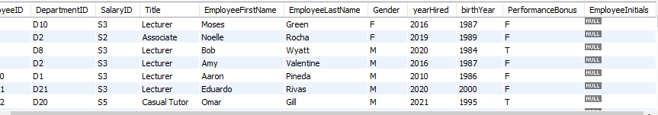

The last column employee initials is added to the database the data it contains is null because it is a newly created attribute and the data is to be added in this column.

### Question 2:

***Display the first names of all employees who work in the department located in Sydney***

**Query**



This is the query of this question where the select command is used, the select command is one of the main commands of the MySql database and most used command to get the data from the tables and work on the table in this query with select the join command is used to get the desired output from the database (*Elmasri, R., Navathe, S.B, ELT 2020*). First, select command select all the first names of the employees, and then join the connect employees table with the department table and get the output on behalf of the department’s location.

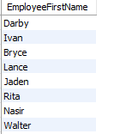

There are more rows but it is just a sample run of the query to get all the employees who are working from Sydney.

### Question 3:

Display employee first and last names and work out the original salary for all employees and their new salary after their (10%) bonus is applied

**Query**

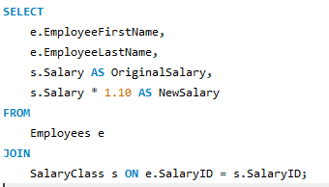

This question is a logical question first, there is to get an employee's first name and last name with their original salary with the select command then it joins with the salaried class and multiplies the salary with the new bonus and shows it on the data schema with first name, last name, original salary and the new salary of each employee. In this question there is also select and join commands are implemented.

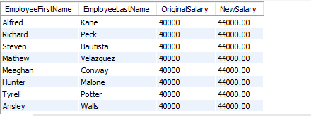

This is the output of the query which have been run in the MySql environment and gets the desired output.

### Question 4:

: Display how many employees will not receive a performance bonus

**Query:**



In this query, the count method is used to calculate all the employees who get no bonus from the company and this count calculates all the employees who get no bonus and subtracts the employees who get their bonus and then it displays a new column named employeeswithnobonus (*Ikromovna, A.Z., 2023*). And in the query, the asterisk sign is used which means all the employees.



So 18 thousand+ employees get no bonus this year.

### Question 5:

Write a query that returns the employees with initials that are a palindrome and also returns employees without palindrome initials, but output 'not a palindrome!'

**Query**:

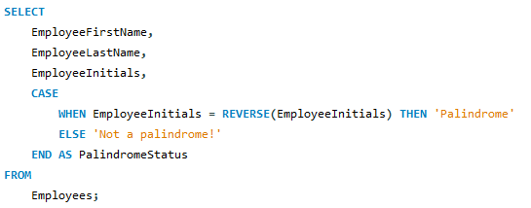

This query returns an employee with their initials which are palindrome and these employees are stored in the database. The first select command is run and after this select there handles all the records and gets the records that are needed like if the employee's name is in palindromic then returns palindrome else return not a palindrome and then give it final status.

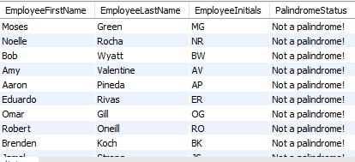

### Question 6:

Write a query that populates EmployeeInitials, based on the existing stored names

**Query:**



This question updates the whole table of employees and sets values to the employee initials columns like adding the initials of the employees in the desired column now based on this table further work can be done. For this question, the update command is used and this update command is used when there is a need to change the data of the tables and wants to update the old content of the table with the new content. With this update, one more command is used which is CONCAT this command adds both name initials in one and shows the output.

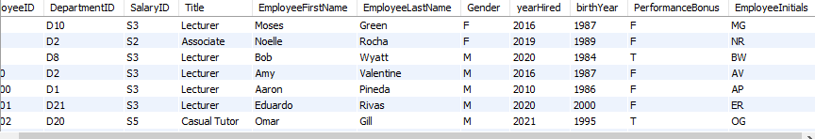

Can see the last column the update command updates all the row records as it need to be shown.

### Question 7:

In the whole database work the joins are used in the queries to get the output from the database as an inner join. First, see what are joins for a better understanding of this question, joins are one of the main concepts in the relational database management system, the joins join one or more tables and give the desired output that is needed, these join make the work easy to write big queries and give the answer in small queries. There are a lot of joins used in the database management system including outer join, inner join, cross join, and full join all the joins are used based on the specific requirements. If the user wants to get the whole database record they can use the joins or want a specific column they can use joins based on their needs.

Now in this database, the join is implemented as an inner join.

#### Inner Join:

Inner join is one type of join it is used when a user wants a record and the record matches on both tables this join works on the IDs like there is one primary key in one table and another table is a foreign key and gets the same records from both tables.

It ensures that all the records that are gotten from both tables are matched with each other.

* In this database, the salary class and employee table join and all the records are got by using inner join.
* In this database the employee and department table join and all the records are got by the inner join.

Would other joins have worked?

Other types of joins have also been used depending on the specific needs and the relationship that they want to perform with the joins. The other join that can be implemented are cross, left join, and full outer join.

* The left join retrieves all the information of the employees regardless of whether this information is associated with salary or department the left join might be used in this scenario (*Emerson, S.L., Darnovsky, ELT 2020*).
* If a user wants to retrieve all the information including those information which are not related to salary and department information a full outer join can be used and best fitted for this case.
* If a user wants to do a cartesian product, combining each row from the employees' table with the row of the salary table or department table a cross join might be used in this scenario.

So the last is each of the joins can be used but according to and depending on the requirements and needs of the joins.

### Question 8:

Write 250 words explaining the integrity of this database. Is it up to standards? If yes, explain why and how. If not, what is wrong with the database's integrity?

The integrity of the database system is based on the accuracy, scalability, and reliability of its data. Maintaining the integrity of the database is the most important task in the management system for better database design. There is a need to maintain the database integrity of the database. For this integrity, there is a need to ensure various things including table structure, relations between the tables, and the overall data quality. If these things are well maintained the integrity of the data will also be maintained. Few things contribute to database integrity and these are defined as follows:

### Table Structure:

This employee management system database includes multiple tables including employees, salary classes, and departments, and each of the tables have their appropriate column names and data (*Rockoff, L., 2021*). This well-maintained structure approach helps to ensure the integrity of the database.

### Primary Key:

The primary key is the second measure of maintaining integrity, there are primary keys defined with each table, for example, employee ID, department ID, etc. These primary keys make all the data unique and ensure data integrity by preventing duplicate entries.

### Foreign Key:

This is the third part of ensuring the data integrity, the foreign key maintains the relationship between the tables such as the relation between the employee and salary class table with the help of employee ID.

### Data Validation:

There are various columns are created that allow data validation and these columns include a gender column in the employee table which only allows values such as (M, F, and O) for males, females, and others. This helps in maintaining the accuracy and consistency of the database.

# Conclusion:

Data is the most precious asset of every organization because in this data there is information about the company’s revenue, employees’ information, and various other precious information so for this data, there is a need for a system that helps to maintain this data and allows to enhance the accuracy, consistency, and scalability of the work. For this in the early 19’s database was developed which take place of old file management systems. Database is one of the important parts of an organization because it handles all the data of the organization, these databases handle all sorts of data and maintain the data so it can be used in the future as well. In this assessment, the work is related to handling employee data and performing some queries on this database to find out the desired output. These databases play a vital role and in all companies, there are separate sections for this the companies hire the database developer which handles all the data of these companies and protects the data from external harm. This report will help to understand how databases will help in such organizations manage all the data as needed and provide data integrity. All of the questions are answered with their queries and output in this report.

# References:

Gjerding, M.N., Taghizadeh, A., Rasmussen, A., Ali, S., Bertoldo, F., Deilmann, T., Knøsgaard, N.R., Kruse, M., Larsen, A.H., Manti, S. and Pedersen, T.G., 2021. Recent progress of the computational 2D materials database (C2DB). *2D Materials*, *8*(4), p.044002.

Elmasri, R., Navathe, S.B., Elmasri, R. and Navathe, S.B., 2020, August. Fundamentals of Database Systems</Title. In *Advances in Databases and Information Systems: 24th European Conference, ADBIS 2020, Lyon, France, August 25–27, 2020, Proceedings* (Vol. 12245, p. 139). Springer Nature.

Ikromovna, A.Z., 2023. SQL (STRUCTURED QUERY LANGUAGE) CAPABILITIES OF THE STATISTICAL DATABASE LANGUAGE. *Multidisciplinary Journal of Science and Technology*, *3*(5), pp.274-280.

Emerson, S.L., Darnovsky, M. and Bowman, J., 2020. *The practical SQL handbook: using a structured query language*. Addison-Wesley Longman Publishing Co., Inc..

Rockoff, L., 2021. *The language of SQL*. Addison-Wesley Professional.